Below is suggested social media copy (image options attached) to help you promote this month’s health and wellness topic – Managing Stress – among your members. Please feel free to share this on your internal communication platforms and via your own LinkedIn accounts, as appropriate.

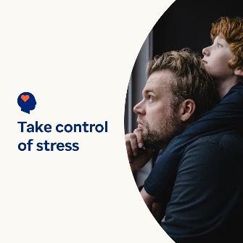

- 7th April is World Health Day. Have a look at these self-help tips for managing stress and protecting your health and wellbeing. optumwellbeing.com/newthismonth/en-GB #employeehealth #wellbeing #worldhealthday

- Stress is natural, but you can take more control over how much it affects your life. This article offers practical approaches for taking some of the pressure off yourself. optumwellbeing.com/newthismonth/en-GB #employeehealth #wellbeing #worldhealthday

- Looking for a fun way to reduce stress? Make your own sensory playtime fun! Here’s a simple recipe for playdough which uses common ingredients. optumwellbeing.com/newthismonth/en-GB #employeehealth #wellbeing #worldhealthday

- It’s a fact: Pets can make your life better. Learn how as well as how to determine whether getting a pet is right for you. optumwellbeing.com/newthismonth/en-GB #employeehealth #wellbeing #worldhealthday

How to post on LinkedIn:
- Open your LinkedIn account.
- Select your preferred text (including link) from above. Copy + Paste.
- Choose your preferred image and add it to your post (save the image to your drive, select ‘Add photo’ before the next step).
- Click ‘Post’.

