Below is suggested social media copy (image options attached) to help you promote this month’s health and wellness topic — Managing stress, anxiety and panic — among your members. Feel free to share on your internal communication platforms and via your own LinkedIn accounts, as appropriate.

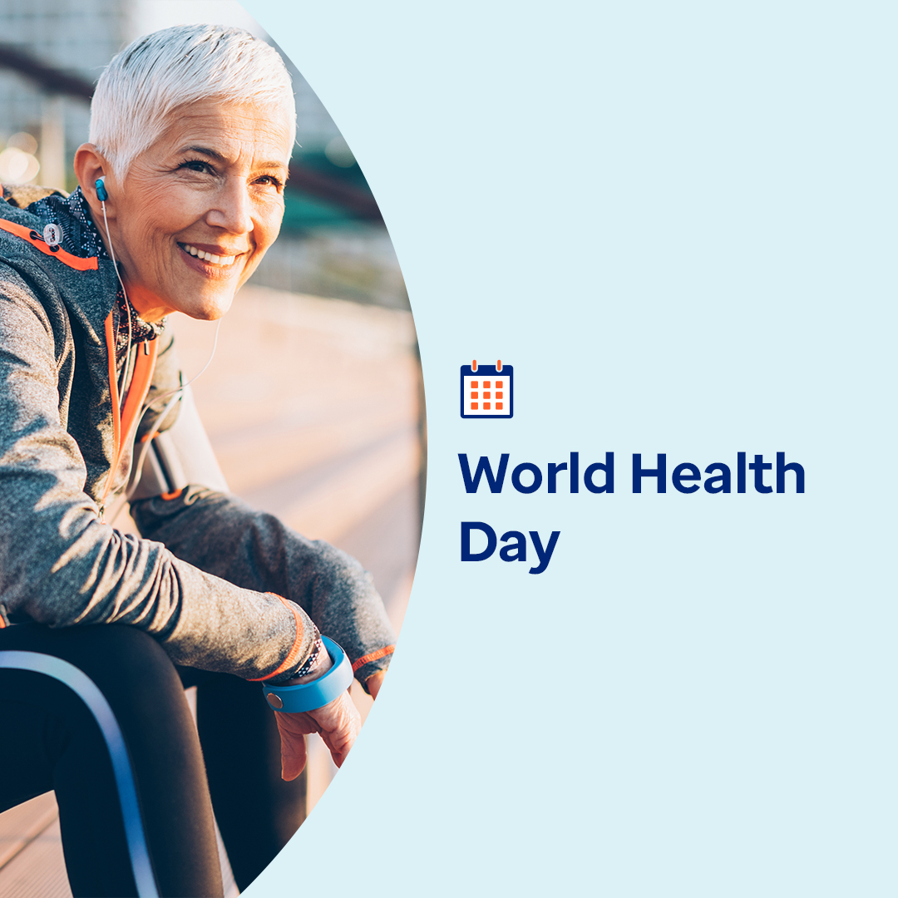

Image 1 Image 2 Image 3 Image 4

- April 7 is World Health Day. This month, discover proven, practical and fun ways to relieve stress, ease your mind and nurture calm. optumwellbeing.com/newthismonth/en-US #employeehealth #wellbeing #WorldHealthDay2025

- Looking for enjoyable ways to find calm? This month’s toolkit offers breathing, music and coloring exercises to help you. optumwellbeing.com/newthismonth/en-US #employeehealth #wellbeing #WorldHealthDay2025

- Explore how to control what you can, nurture positivity and build resilience to help manage stress in this month’s toolkit. optumwellbeing.com/newthismonth/en-US #employeehealth #wellbeing #WorldHealthDay2025

- Discover the history of World Health Day and how you can help shape its future and carry its “health for all” mission forward. optumwellbeing.com/newthismonth/en-US #employeehealth #wellbeing #WorldHealthDay2025

How to post on LinkedIn:
- Open your LinkedIn account.
- Select your preferred text (including link) from above. Copy + paste.
- Choose your preferred image and add to your post (save image to your drive, select “add photo” prior to step 4.
- Click “post.”

