Below is suggested social media copy (image options attached) to help you promote this month’s health and wellness topic – Youth Mental Health – amongst your members. Please feel free to share this on your internal communication platforms and via your own LinkedIn accounts, as appropriate.

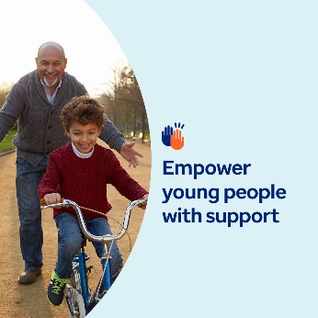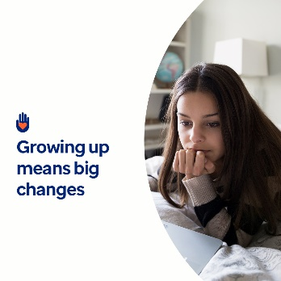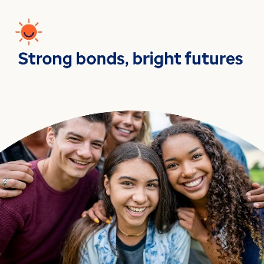

- Growing up can feel overwhelming. This month, explore resources (articles, activities and training tools) to understand better what the young people in your life may be experiencing emotionally and mentally, and how to support them. optumwellbeing.com/newthismonth/en-GB #employeehealth #wellbeing #mentalhealthawareness

- While caring for children and adolescents, we can sometimes forget how hormonal changes inside them affect their emotions and actions on the outside. Here’s a refresher, along with tips for supporting them as they grow. optumwellbeing.com/newthismonth/en-GB #employeehealth #wellbeing #mentalhealthawareness

- Did you know that encouraging young people to make friends from different backgrounds leads to happier lives and stronger communities? Learn why in this month’s toolkit. optumwellbeing.com/newthismonth/en-GB#employeehealth #wellbeing #mentalhealthawareness

- Giving your child a break from school or activities can help them recharge and reset. This month’s toolkit offers insights into recognising when time away might be in order and what to consider when planning it. optumwellbeing.com/newthismonth/en-GB #employeehealth #wellbeing #mentalhealthawareness

How to post on LinkedIn:
- Open your LinkedIn account
- Select your preferred text (including link) from above. Copy + Paste
- Choose your preferred image and add it to your post (save the image to your drive, select ‘Add photo’ prior to step 4)
- Click ‘Post’

