Below is suggested social media copy (image options attached) to help you promote this month’s health and wellness topic – Being present – among your members. Feel free to share on your internal communication platforms and via your own LinkedIn accounts, as appropriate.

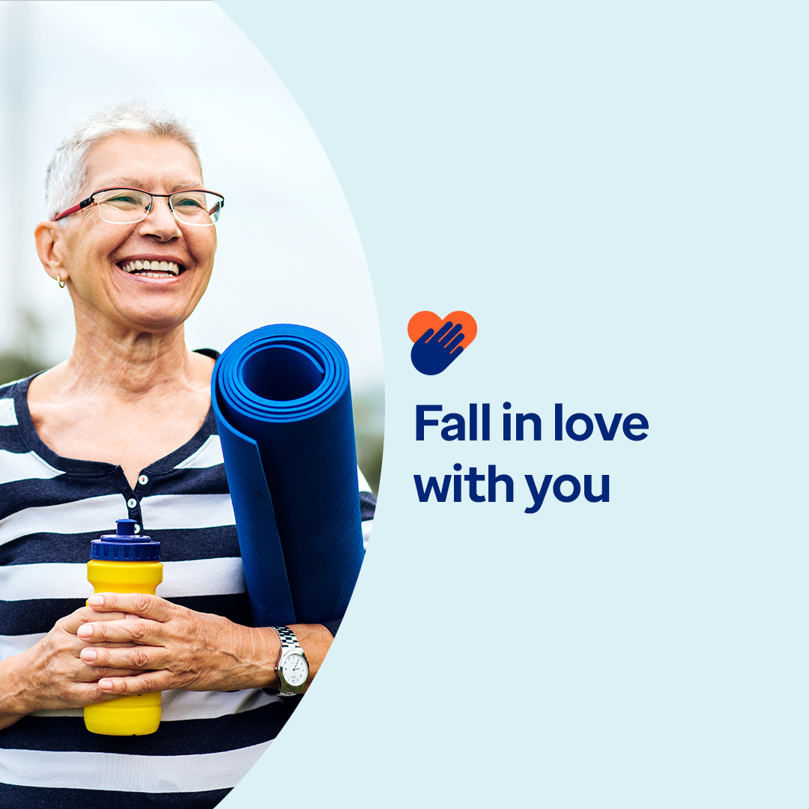


- Could you love yourself more? Discover why self-love is essential and how to nurture it in this month’s toolkit. optumwellbeing.com/newthismonth/en-US #employeehealth #wellbeing #mentalhealthawareness #MentalHealthMatters

- Taking time to be present can help you find calm, clarity and a path to move forward. Learn why and how to get started in this month’s toolkit. optumwellbeing.com/newthismonth/en-US #employeehealth #wellbeing #MentalHealthMatters

- Practicing self-compassion, gratitude and mindfulness can boost your mental health and well-being. Check out the daily acts of self-love calendar in this month’s toolkit to get started. optumwellbeing.com/newthismonth/en-US #employeehealth #wellbeing #MentalHealthMatters

- Ever feel lonely? You’re not alone. Many of us experience this painful emotion, especially during the holidays or major life transitions. This month’s toolkit shares insight on what drives loneliness and offers suggestions for navigating it. optumwellbeing.com/newthismonth/en-US #employeehealth #wellbeing #MentalHealthMatters

- Life is full of distractions – check out these tips for tuning them out, so you can tune into yourself. optumwellbeing.com/newthismonth/en-US #employeehealth #wellbeing #MentalHealthMatters

How to post on LinkedIn:
- Open your LinkedIn account
- Select your preferred text (including link) from above. Copy + paste
- Choose your preferred image and add to your post (save image to your drive, select “add photo” prior to step 4
- Click “post”

