Below is suggested social media copy (image options attached) to help you promote this month’s health and wellness topic – Mind-body wellness connection – among your members. Feel free to share on your internal communication platforms and via your own LinkedIn accounts, as appropriate.

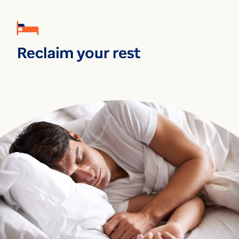
Image 1 Image 2 Image 3 Image 4

- While you can’t control every aspect of life, creating a routine can benefit your mental health and wellbeing. Use this guide and worksheet to build a routine that’s easy to stick to. optumwellbeing.com/newthismonth/en-US #employeehealth #wellbeing

- Do you know what “glimmers” are? They’re moments you can practice capturing to feel more joy and comfort in your life. Learn more in this month’s toolkit. optumwellbeing.com/newthismonth/en-US #employeehealth #wellbeing

- About one-third of adults globally do not get enough quality sleep. Use this interactive worksheet to create a sleep plan. Then challenge yourself to sleep better in January and beyond. optumwellbeing.com/newthismonth/en-US #employeehealth #wellbeing

- Feeling “stuck” in your professional, personal or emotional life? Here are some tips to help you get “unstuck” and reset. optumwellbeing.com/newthismonth/en-US #employeehealth #wellbeing

How to post on LinkedIn:
- Open your LinkedIn account
- Select your preferred text (including link) from above. Copy + paste
- Choose your preferred image and add to your post (save image to your drive, select “add photo” prior to step 4
- Click “post”

