Below is suggested social media copy (image options attached) to help you promote this month’s health and wellness topic — Welcoming your uniqueness — among your members. Feel free to share on your internal communication platforms and via your own LinkedIn accounts, as appropriate.

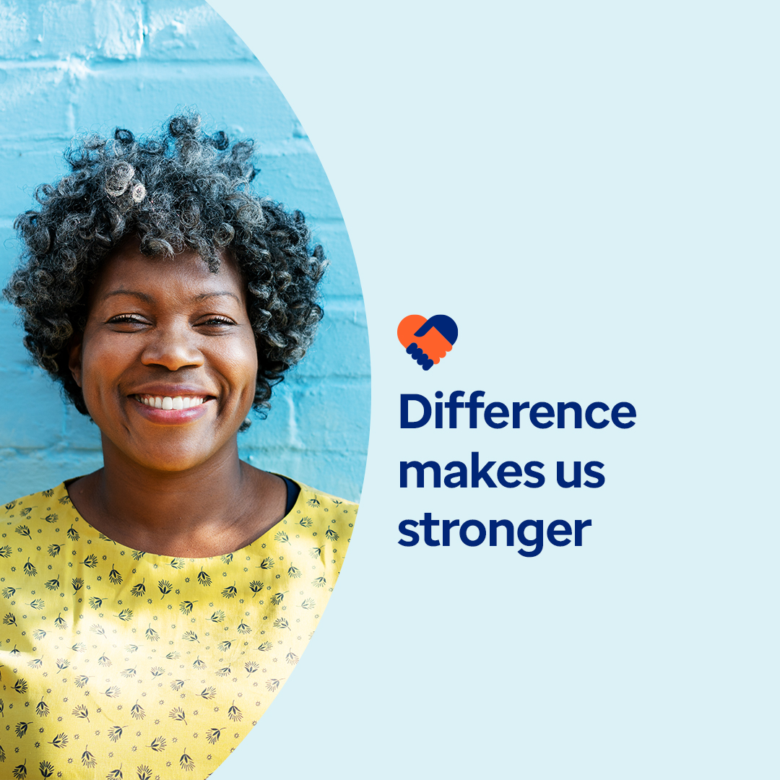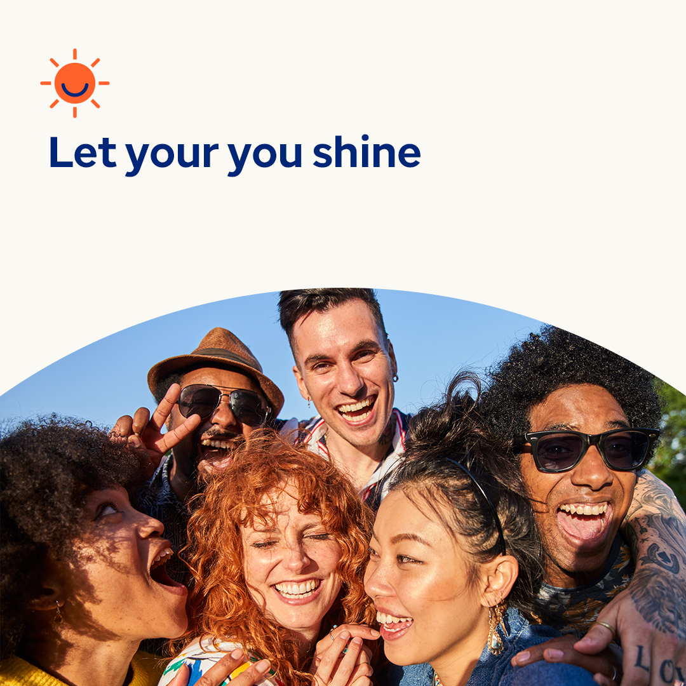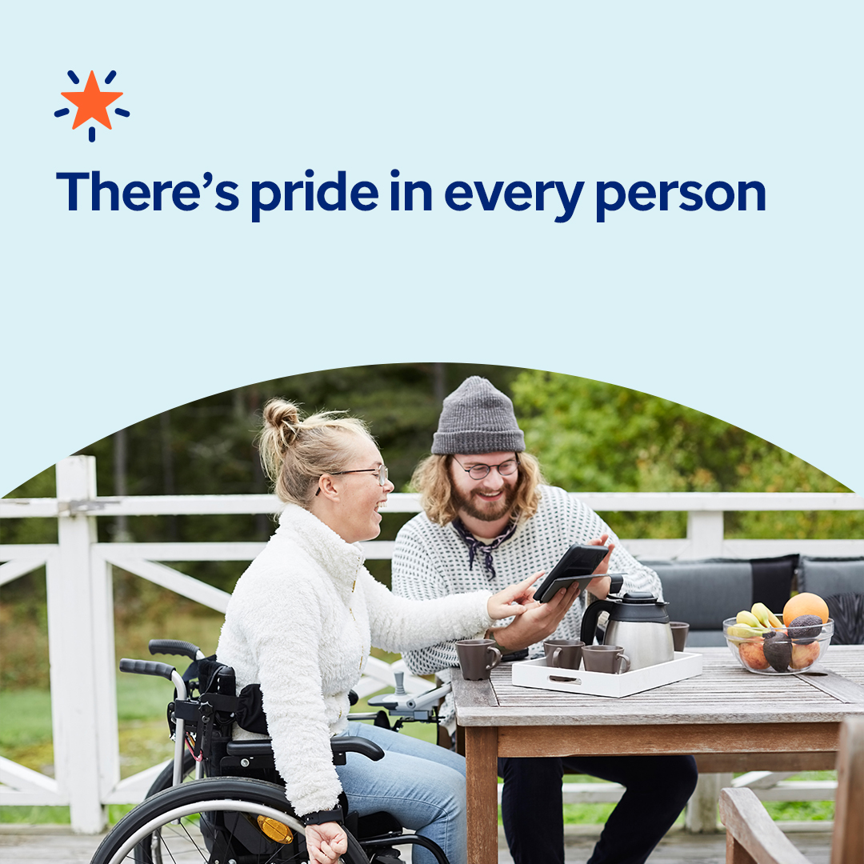
Image 1 Image 2 Image 3 Image 4

- Every person is unique inside and out — and that’s a good thing. In this month’s toolkit, explore resources to help you understand and value yourself and others better. optumwellbeing.com/newthismonth/en-US #employeehealth #wellbeing

- If you’re like many people, you may be holding onto beliefs about mental health that stop you or others from getting support. Learn about some of the common misconceptions and how to help challenge them in this month’s toolkit. optumwellbeing.com/newthismonth/en-US #employeehealth #wellbeing

- You’re one of a kind. Use this fun activity to explore who you are. You can do it on your own or with family and friends to get to know one another better. optumwellbeing.com/newthismonth/en-US #employeehealth #wellbeing

- July is Disability Pride Month. Learn why we celebrate this month — and how to support the millions of individuals it honors. optumwellbeing.com/newthismonth/en-US #employeehealth #wellbeing

How to post on LinkedIn:
- Open your LinkedIn account.
- Select your preferred text (including link) from above. Copy + paste.
- Choose your preferred image and add to your post (save image to your drive, select “add photo” prior to step 4.
- Click “post.”

