Below is suggested social media copy (image options attached) to help you promote this month’s health and wellness topic — women’s mental health — among your members. Feel free to share on your internal communication platforms and at your own LinkedIn accounts, as appropriate.

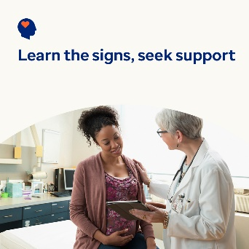

- March 8 is International Women’s Day. Learn how you can help support the mental health and wellbeing of the women in your life, through major life transitions and challenges. optumwellbeing.com/newthismonth/en-US #employeehealth #wellbeing #internationalwomensday #IWD2024

- If you’re struggling with infertility, no one can tell you how to feel or what to do. But hopefully, reading this will help you get through what you’re going through and feel supported. optumwellbeing.com/newthismonth/en-US #employeehealth #wellbeing #internationalwomensday #IWD2024

- Globally, many women who are pregnant or have just given birth experience depression and anxiety — both of which are treatable. Learn about the signs and symptoms as well as self-help and professional treatment options. optumwellbeing.com/newthismonth/en-US #employeehealth #wellbeing #internationalwomensday #IWD2024

- Menopause is a natural biological process that typically happens as women age. Yet, very few people talk about it. Help get the conversation started — read this quick overview of what to expect during menopause. optumwellbeing.com/newthismonth/en-US #employeehealth #wellbeing #internationalwomensday #IWD2024

How to post on LinkedIn:
- Open your LinkedIn account.
- Select your preferred text (including link) from above. Copy + paste.
- Choose your preferred image and add to your post (save image to your drive, select “Add photo” prior to step 4).
- Click “Post”.

