Below is suggested social media copy (image options attached) to help you promote this month’s health and wellness topic — Mental Health Awareness — among your members. Please feel free to share this on your internal communication platforms and via your own LinkedIn accounts, as appropriate.

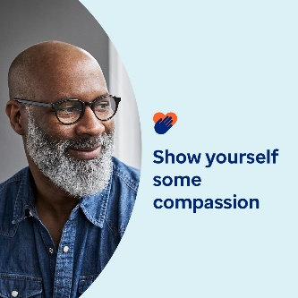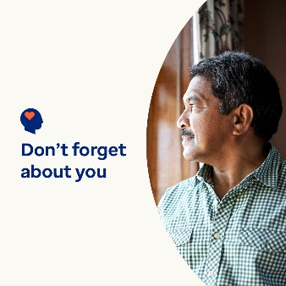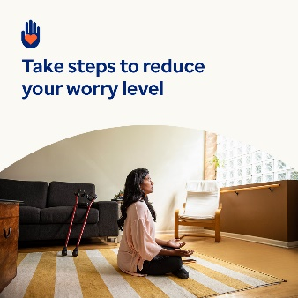

- Being a caregiver is a big responsibility. But it’s crucial to take care of yourself too. In this month’s toolkit, you’ll find resources, tips and tools for self-care and showing yourself compassion. optumwellbeing.com/newthismonth/en-GB #employeehealth #wellbeing

- Are you a ‘sandwich generation’ caregiver? Learn how and why you should show yourself more compassion. optumwellbeing.com/newthismonth/en-GB #employeehealth #wellbeing

- Do you waste time at the weekend worrying about the working week? Try this activity for turning those thoughts around. optumwellbeing.com/newthismonth/en-GB #employeehealth #wellbeing

- Get tips on finding a therapist that’s right for you. optumwellbeing.com/newthismonth/en-GB #employeehealth #wellbeing #worldhealthday

How to post on LinkedIn:
- Open your LinkedIn account
- Select your preferred text (including link) from above. Copy + Paste
- Choose your preferred image and add it to your post (save the image to your drive, select ‘Add photo’ prior to step 4)
- Click ‘Post’

