Below is suggested social media copy (image options attached) to help you promote this month’s health and wellness topic – men’s mental health – amongst your members. Please feel free to share this on your internal communication platforms and via your own LinkedIn accounts, as appropriate.

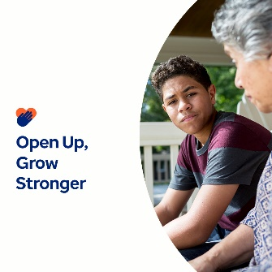

- Explore the resources in this month’s toolkit, which challenge mental health stigma and stereotypes and empower everyone to support mental wellbeing with compassion. optumwellbeing.com/newthismonth/en-GB #employeehealth #wellbeing #mentalhealthawareness #MentalHealthMatters

- Find out why it’s important to open up emotionally and four ways to get started in this month’s toolkit. optumwellbeing.com/newthismonth/en-GB ] #employeehealth #wellbeing #MentalHealthMatters

- Discover how men and women experience mental health concerns differently in this month’s toolkit. optumwellbeing.com/newthismonth/en-GB #employeehealth #wellbeing #MentalHealthMatters

- Try these 8 great ways to nurture your own emotional wellbeing. Check out this month’s toolkit. optumwellbeing.com/newthismonth/en-GB #employeehealth #wellbeing #MentalHealthMatters

How to post on LinkedIn:
- Open your LinkedIn account.
- Select your preferred text (including link) from above. Copy + Paste.
- Choose your preferred image and add it to your post (save the image to your drive, select ‘Add photo’ prior to step 4).
- Click ‘Post’.

