Below is suggested social media copy (image options attached) to help you promote this month’s health and wellness topic – Men’s Mental Health – among your members. Feel free to share on your internal communication platforms and via your own LinkedIn accounts, as appropriate.

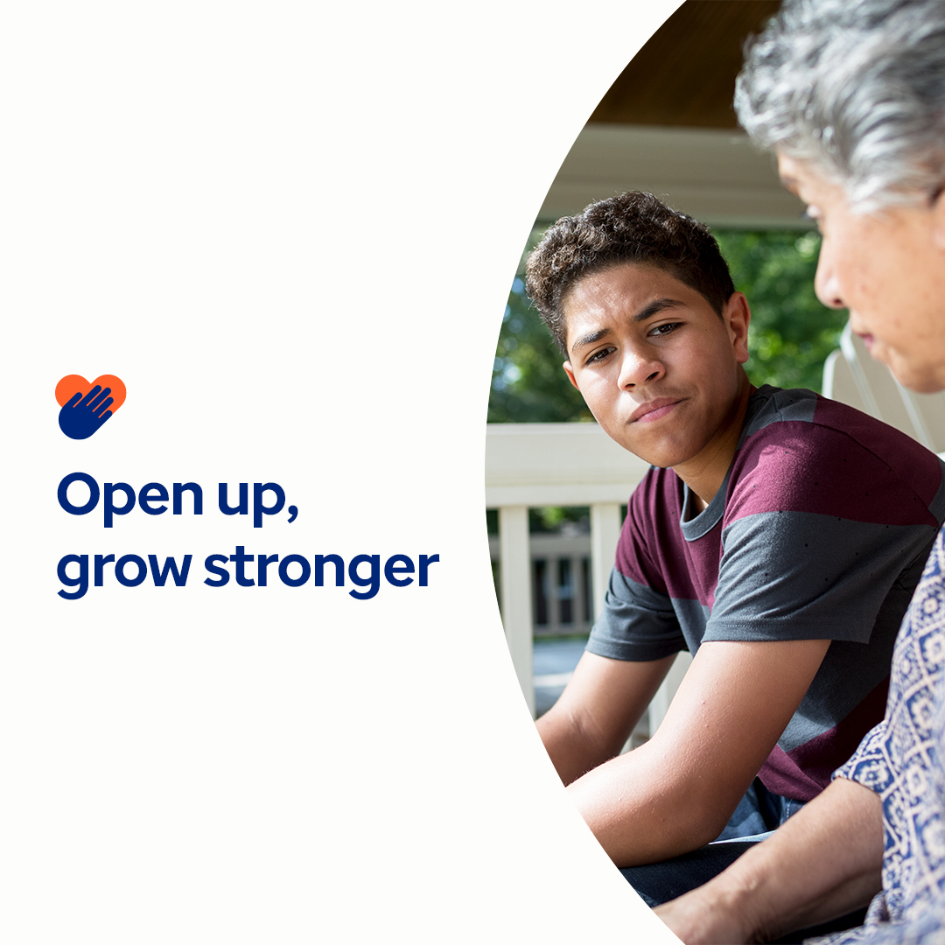

- Explore resources in this month’s toolkit that challenge mental health stigma and stereotypes and empower everyone to support mental well-being with compassion. optumwellbeing.com/newthismonth/en-US #employeehealth #wellbeing #mentalhealthawareness #MentalHealthMatters

- Learn why it’s important to open up emotionally and four ways to get started in this month’s toolkit. optumwellbeing.com/newthismonth/en-US #employeehealth #wellbeing #MentalHealthMatters

- Find out how men and women experience mental health concerns differently in this month’s toolkit. optumwellbeing.com/newthismonth/en-US #employeehealth #wellbeing #MentalHealthMatters

- Try these 8 great ways to nurture your own emotional well-being. Check out this month’s toolkit. optumwellbeing.com/newthismonth/en-US #employeehealth #wellbeing #MentalHealthMatters

How to post on LinkedIn:
- Open your LinkedIn account.
- Select your preferred text (including link) from above. Copy + paste.
- Choose your preferred image and add to your post (save image to your drive, select add photo prior to step 4.
- Click Post.

