Below is suggested social media copy (image options attached) to help you promote this month’s health and wellness topic – Managing Stress – among your members. Please feel free to share this on your internal communication platforms and via your own LinkedIn accounts, as appropriate.

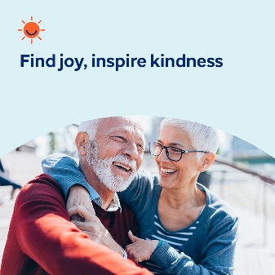

- The 10th of October is World Mental Health Day. Take a moment to learn more about mental health and wellbeing – and how you can help nurture your own mental health and prevent stigma. optumwellbeing.com/newthismonth/en-GB #employeehealth #wellbeing #WorldMentalHealthDay

- Many children and adolescents experience bullying — whether as the victim, the bully or both. Learn more about what motivates bullies and how to prevent them in this month’s toolkit. optumwellbeing.com/newthismonth/en-GB #employeehealth #wellbeing #WorldMentalHealthDay

- Get tips for being the kind of father you hope to be in this month’s toolkit. optumwellbeing.com/newthismonth/en-GB #employeehealth #wellbeing #WorldMentalHealthDay

- Here’s a simple way to take note of the good in you, your life and self-worth, so that you can inspire others to do the same. optumwellbeing.com/newthismonth/en-GB #employeehealth #wellbeing #WorldMentalHealthDay

How to post on LinkedIn:
- Open your LinkedIn account
- Select your preferred text (including link) from above. Copy + Paste
- Choose your preferred image and add it to your post (save the image to your drive, select ‘Add photo’ prior to step 4)
- Click ‘Post’

