Below is suggested social media copy (image options attached) to help you promote this month’s health and wellness topic – World Mental Health – among your members. Please feel free to share this on your internal communication platforms and via your own LinkedIn accounts, as appropriate.

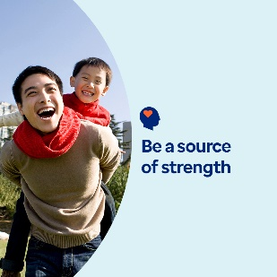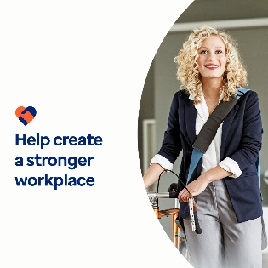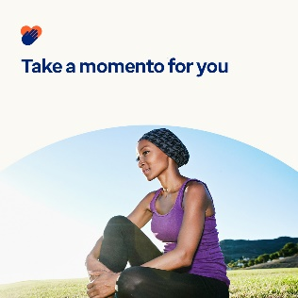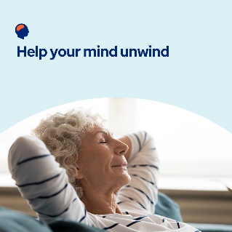

- The 10th of October is World Mental Health Day. In this month’s toolkit, explore resources, tools and tips for nurturing yourself and being a source of openness and strength for others. optumwellbeing.com/newthismonth/en-GB #employeehealth #wellbeing #mentalhealthawareness # WorldMentalHealthDay #MentalHealthMatters

- Explore four ways you can help make your workplace mentally healthier in this month’s toolkit. optumwellbeing.com/newthismonth/en-GB #employeehealth #wellbeing #WorldMentalHealthDay #MentalHealthMatters

- How are you feeling? Use this self-reflection worksheet to have an open, honest conversation with yourself about what’s going well, what could be better and what to look forward to. optumwellbeing.com/newthismonth/en-GB #employeehealth #wellbeing #WorldMentalHealthDay #MentalHealthMatters

- Looking for ways to find calm? This month’s toolkit offers resources for easing panic and anxiety, practising deep breathing and relaxing before bedtime. optumwellbeing.com/newthismonth/en-GB #employeehealth #wellbeing #WorldMentalHealthDay #MentalHealthMatters

How to post on LinkedIn:
- Open your LinkedIn account
- Select your preferred text (including link) from above. Copy + Paste
- Choose your preferred image and add it to your post (save the image to your drive, select ‘Add photo’ prior to step 4)
- Click ‘Post’

