Below is suggested social media copy (image options attached) to help you promote this month’s health and wellness topic — Suicide prevention and recovery — amongst your members. Please feel free to share this on your internal communication platforms and via your own LinkedIn accounts, as appropriate.

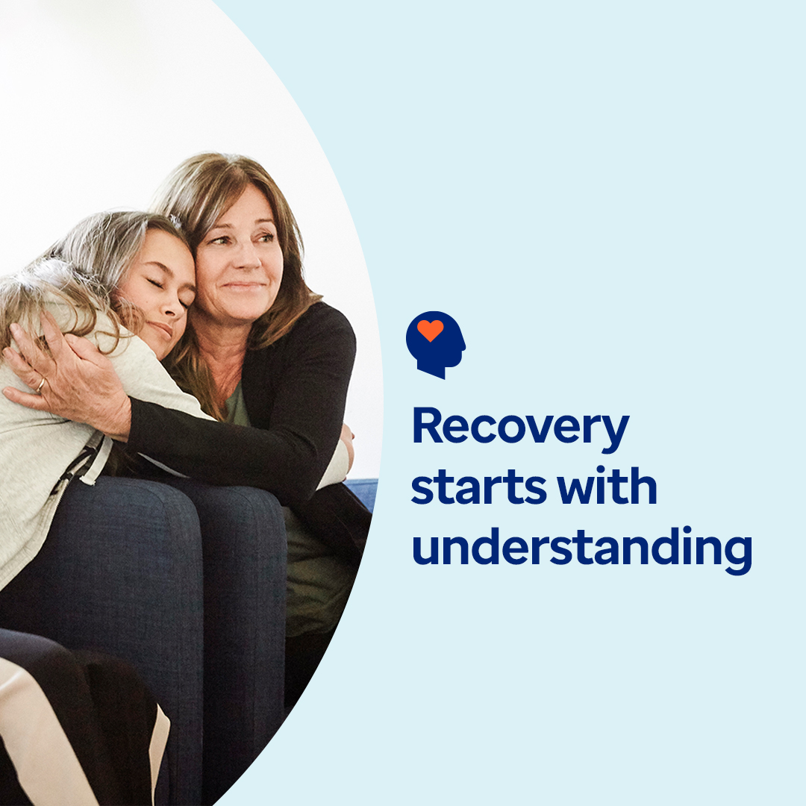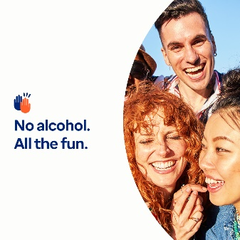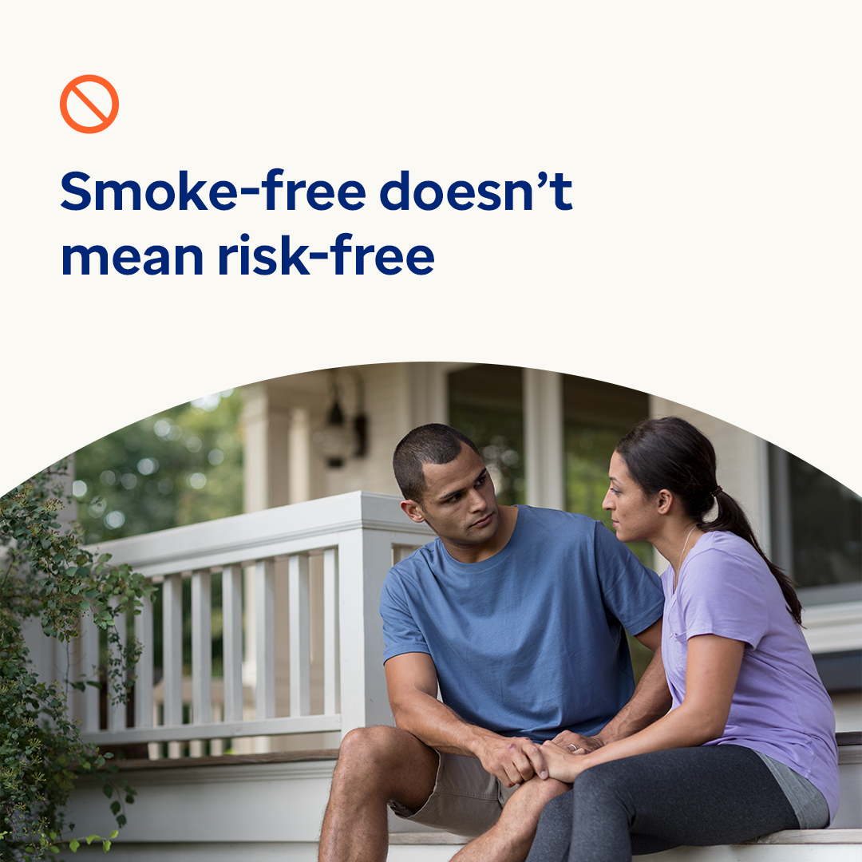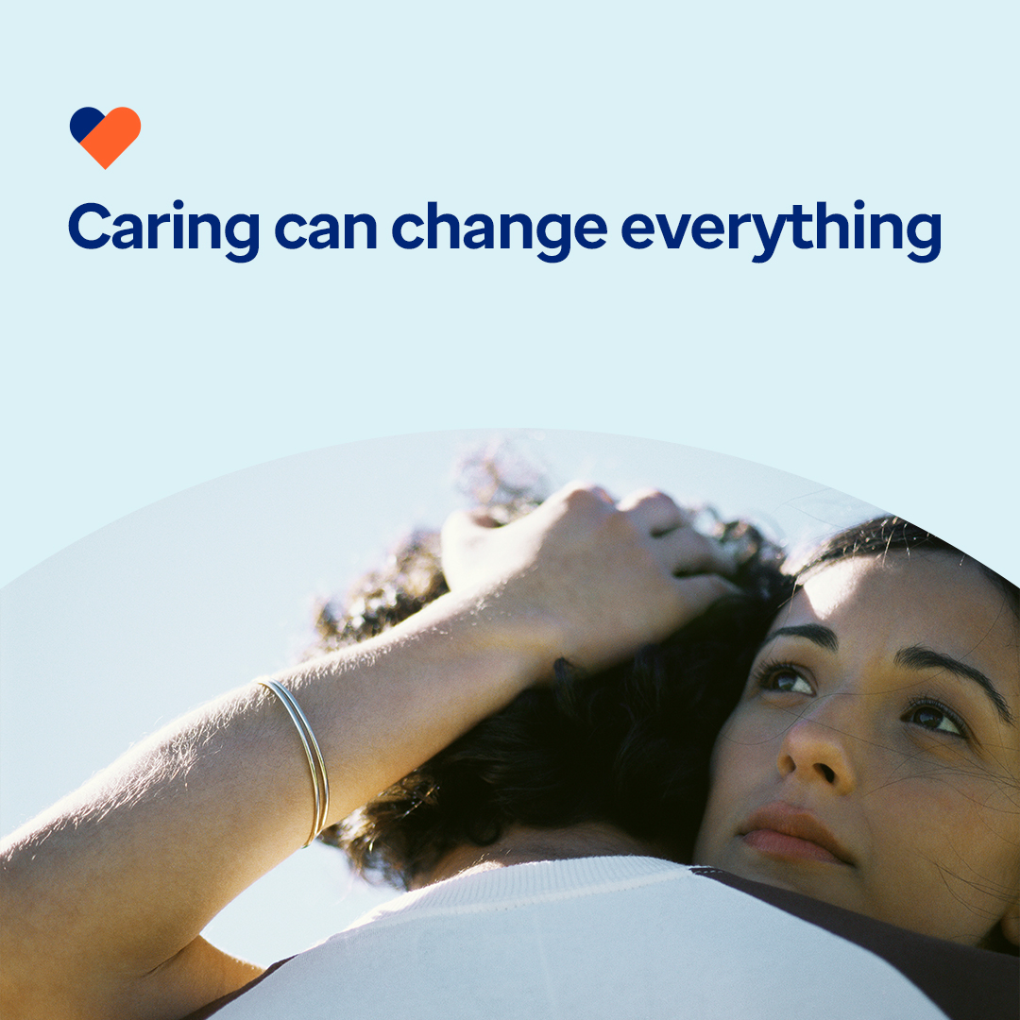

- Addiction is a chronic disease that affects the brain and behaviour. It’s also treatable. Learn what addiction is and how recovery can happen in this month’s toolkit. optumwellbeing.com/newthismonth/en-GB #employeehealth #wellbeing #recoveryjourney #recoveryispossible

- Curious about the ‘sober curious’ movement? Check out this month’s toolkit for an interactive planner to help you craft fun, alcohol-free activities all week long. optumwellbeing.com/newthismonth/en-GB #employeehealth #wellbeing #mentalhealthawareness

- Vaping is often seen as a safer alternative to smoking, but it’s not risk-free. Learn 5 key facts about vaping in this month’s toolkit. optumwellbeing.com/newthismonth/en-GB #employeehealth #wellbeing #mentalhealthawareness

- The 10th of September is World Suicide Prevention Day. While it’s hard to imagine someone you care about struggling with thoughts of suicide, many people around the world do. Learn how you can help raise awareness and save lives in this month’s toolkit. optumwellbeing.com/newthismonth/en-GB #employeehealth #wellbeing #mentalhealthawareness #WSPD

How to post on LinkedIn:
- Open your LinkedIn account
- Select your preferred text (including link) from above. Copy + Paste
- Choose your preferred image and add it to your post (save the image to your drive, select ‘Add photo’ prior to step 4)
- Click ‘Post’

