Below is suggested social media copy (image options attached) to help you promote this month’s health and wellness topic — Suicide prevention and recovery — among your members. Feel free to share on your internal communication platforms and via your own LinkedIn accounts, as appropriate.

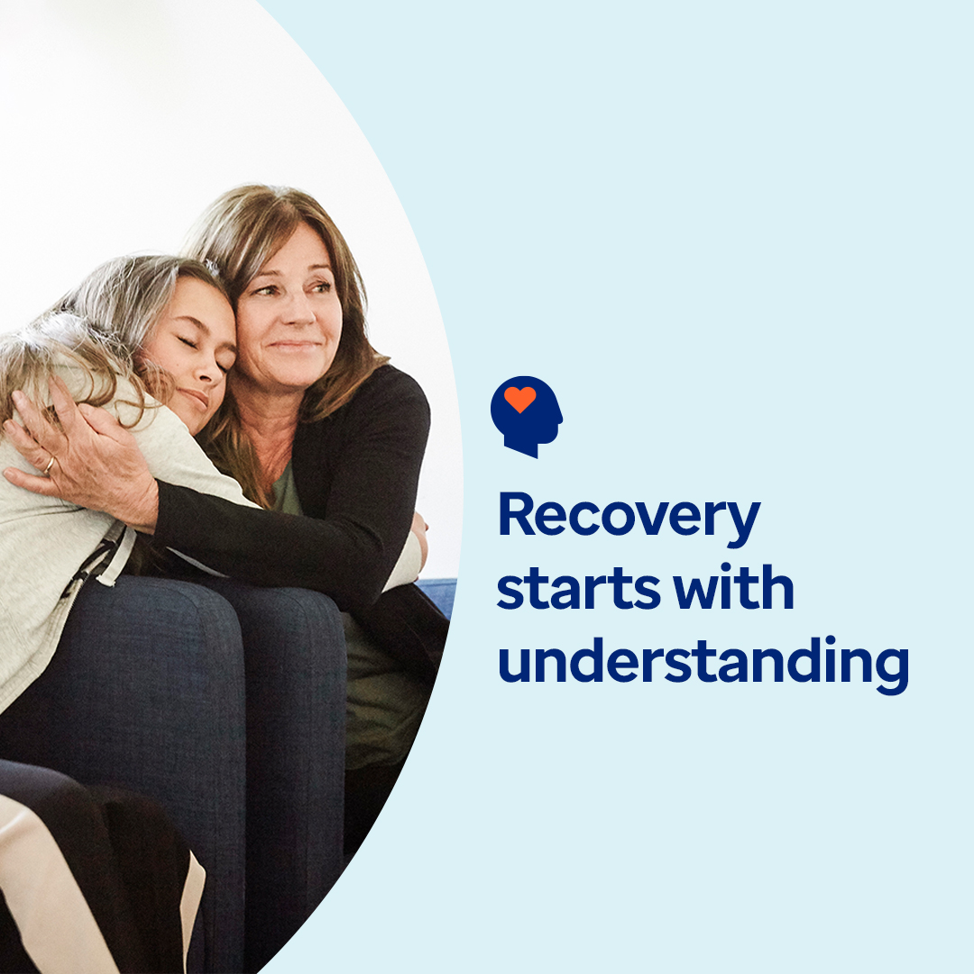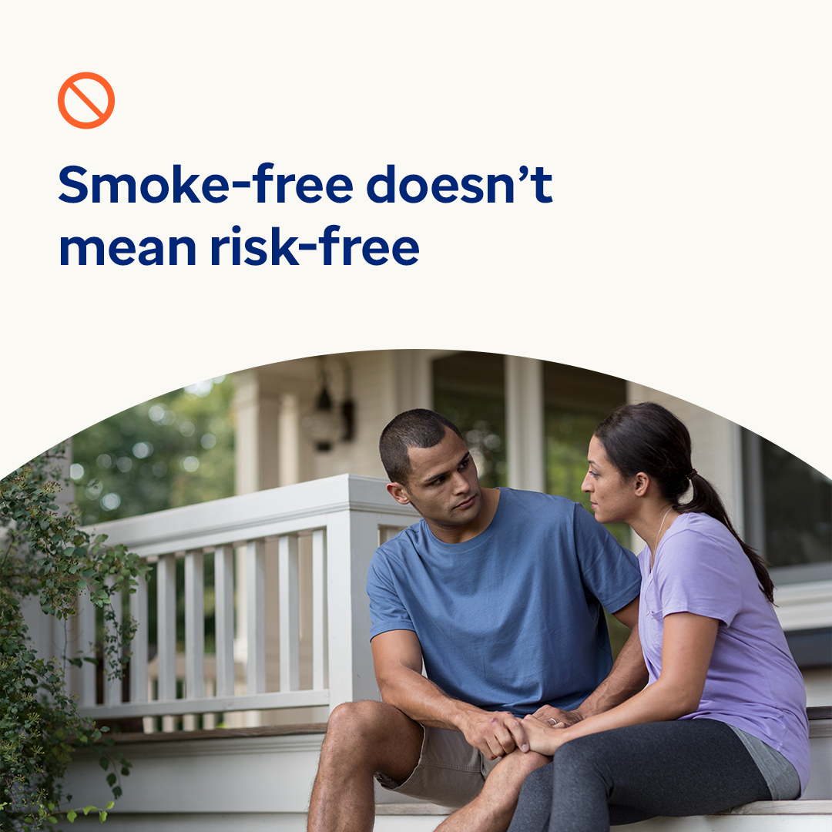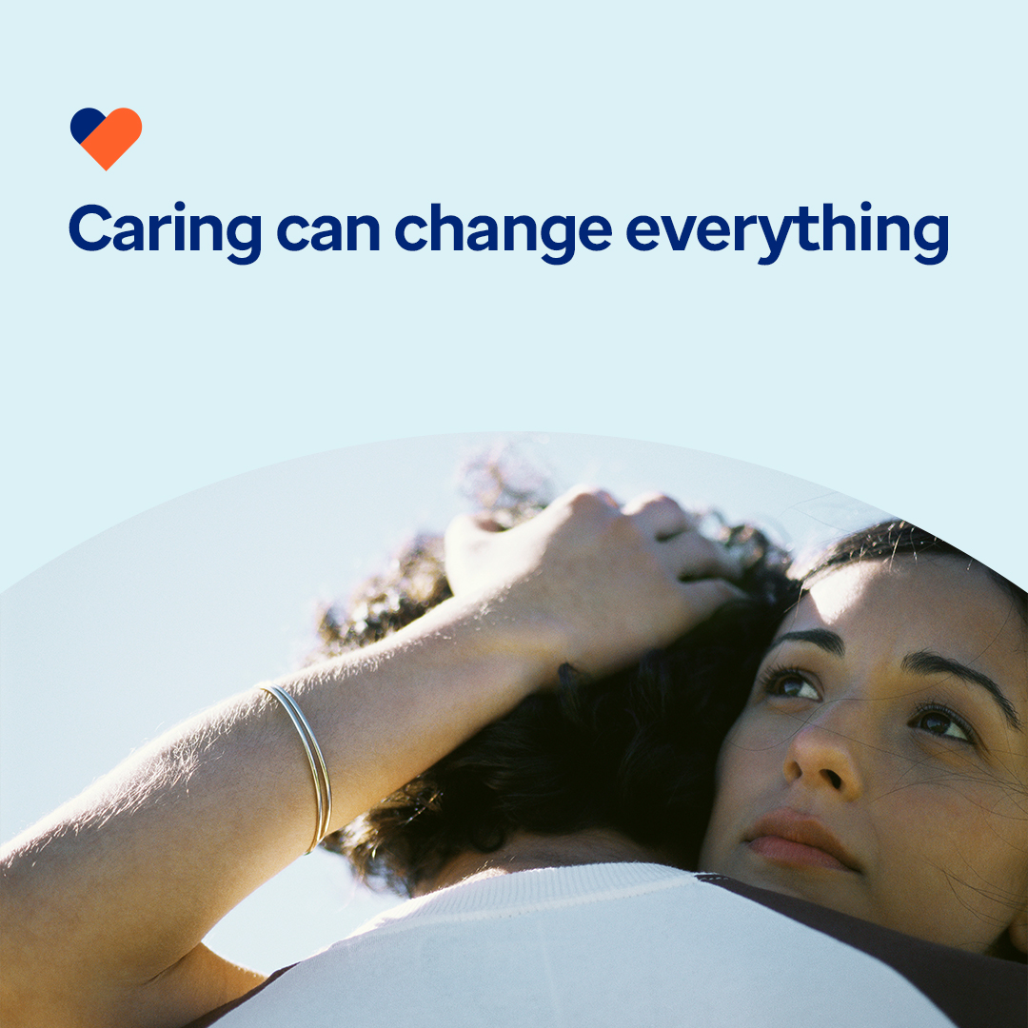
Image 1 Image 2 Image 3 Image 4
- Addiction is a chronic disease that affects the brain and behavior. It’s also treatable. Learn what addiction is and how recovery can happen in this month’s toolkit. optumwellbeing.com/newthismonth/en-US #employeehealth #wellbeing #recoveryjourney #recoveryispossible

- Curious about the ‘sober curious’ movement? Check out this month’s toolkit for an interactive planner to help you craft fun, alcohol-free activities all week long. optumwellbeing.com/newthismonth/en-US #employeehealth #wellbeing #mentalhealthawareness

- Vaping is often seen as a safer alternative to smoking — but it’s not risk free. Learn 5 key facts about vaping in this month’s toolkit. optumwellbeing.com/newthismonth/en-US #employeehealth #wellbeing #mentalhealthawareness

- Sept. 10 is World Suicide Prevention Day. While it’s hard to imagine someone you care about struggling with thoughts of suicide, many people around the world do. Learn how you can help raise awareness and save lives in this month’s toolkit. optumwellbeing.com/newthismonth/en-US #employeehealth #wellbeing #mentalhealthawareness #WSPD

How to post on LinkedIn:
- Open your LinkedIn account
- Select your preferred text (including link) from above. Copy + paste
- Choose your preferred image and add to your post (save image to your drive, select add photo prior to step 4
- Click post

